Db2 DPF Setup Simplified : A Step-by-Step GUI Guide for Linux/AIX

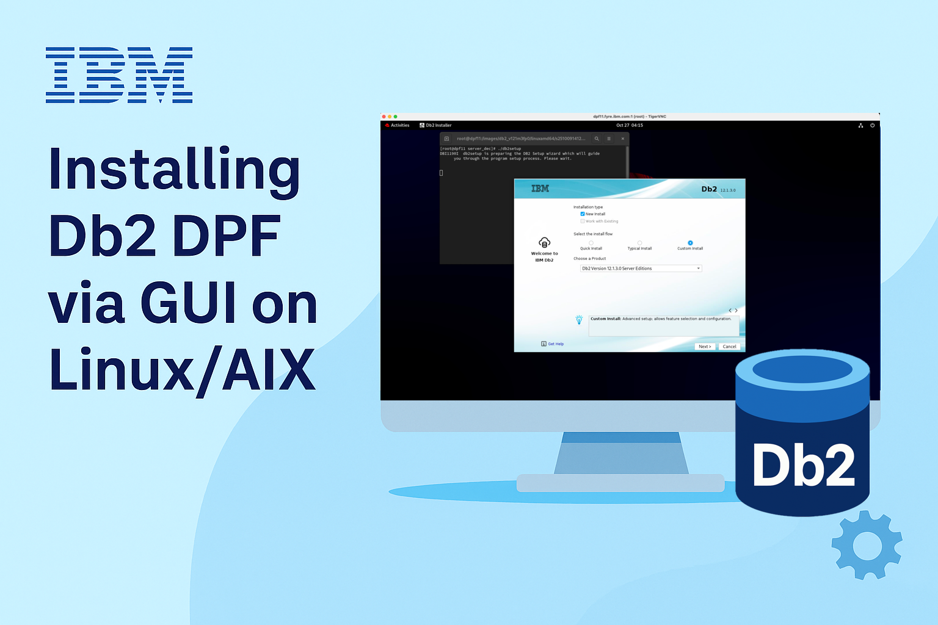

## Setup Db2 DPF with ease

When your data grows, your database should scale with it — that’s where Db2’s Database Partitioning Feature (DPF) comes in. DPF enables high-performance parallel processing by distributing data across multiple partitions, making it ideal for large-scale analytics and data warehousing workloads. It’s built for speed, scalability, and serious performance.

That said, setting up Db2 DPF can sound complex, but with the modernized GUI installer in Db2 version 12.1.3 and later, it’s smooth and easy. If you're working on a Linux/AIX environment and prefer a graphical interface, this blog will walk you through the entire installation process— from launching the GUI installer to configuring multiple partition instances.

Let’s dive in!

## Step-by-step Installation Walkthrough

In a typical Db2 DPF configuration, multiple machines are used to distribute database partitions for parallel processing. The *db2setup* utility for launching the GUI installer must be run on the main DPF host machine (also known as the instance-owning server).

### Kick-off the GUI Installer

On your main DPF host machine, start by launching the *db2setup* utility from the extracted Db2 installation image via your desktop environment.

**Tip:** Need the Db2 installation image or guidance on environment setup and prerequisites? Head to the Wrapping-Up section at the end of this blog for all the details.

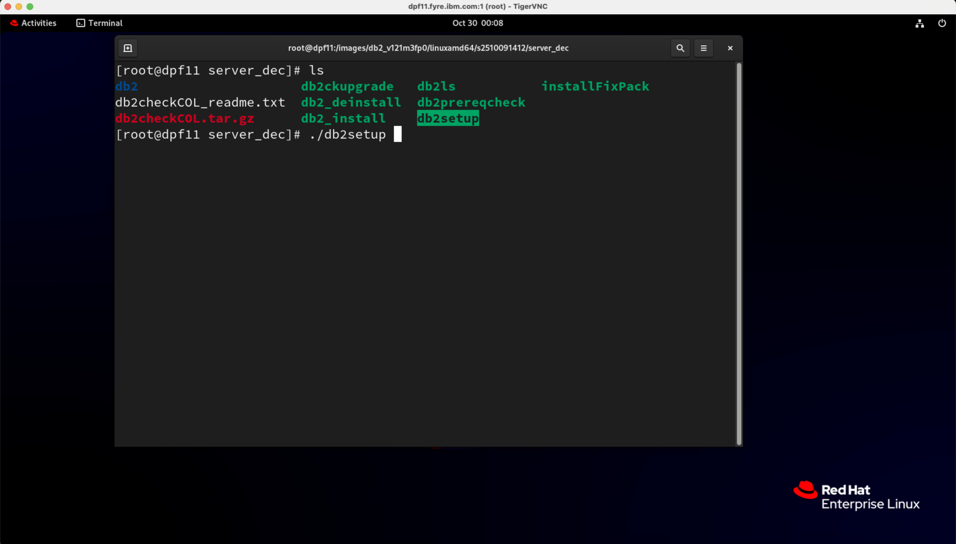

### Say Yes to the License terms

Before diving in, take a moment to review the IBM and non-IBM license agreements. Once you’re ready, click the *I agree* radio button to move to the next step.

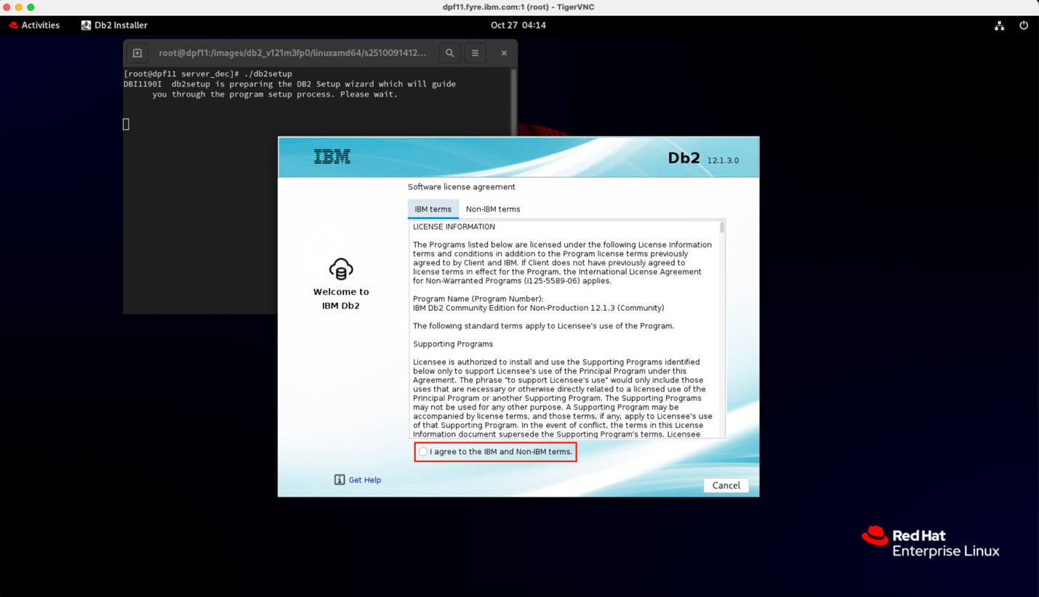

### Go Custom with Db2 Server Edition

On the Installation type screen, choose *Custom Install* as the install flow – this gives you the flexibility to setup your multiple partition instance. From the product drop-down, select *Db2 Server Edition*. Hit *Next* to get started with DPF configuration.

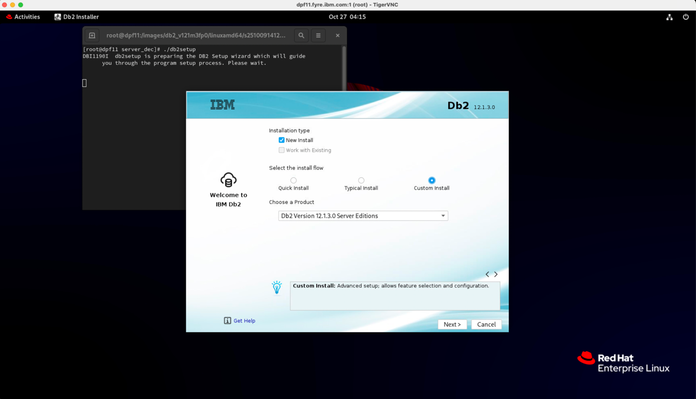

### The Parallel Power Step – Multiple partition setup

On the *Configuration* screen, it’s time to tune your setup for DPF.

* Install directory: Update the installation path pre-filled by the installer if necessary.
* Database partitioning: Select *Multiple partition instance* – this is the key to unlocking Db2’s parallel processing power.

**Tip:** Make sure ***“Create an instance”*** option is selected - this saves you from manual configuration later.

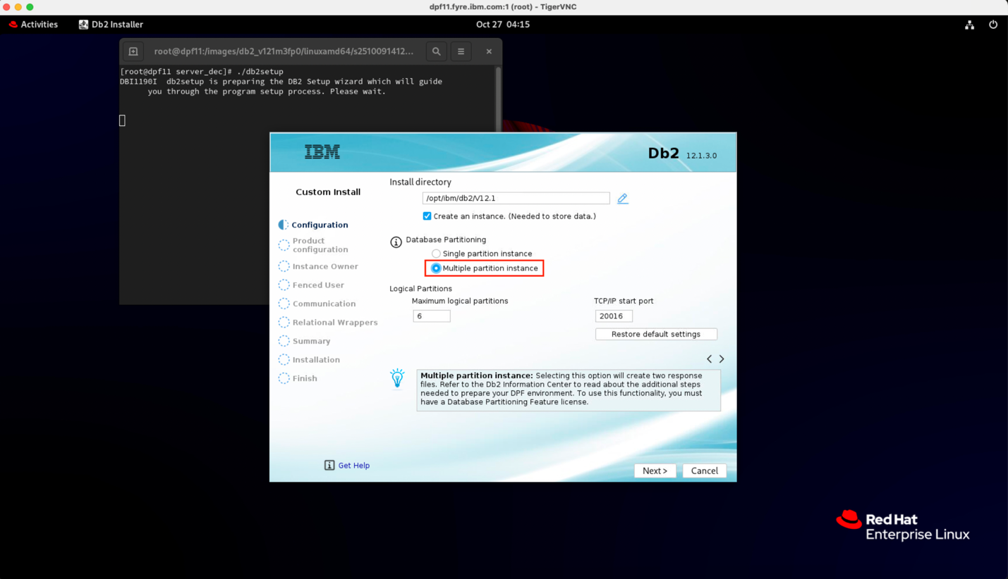

### Fine-Tune your Features

On the *Product Configuration* screen, you get to choose the languages and features that will shape your Db2 experience.

* Default selections: Typically sufficient for most environments, so you can confidently leave them as is. However….
* Feeling Adventurous? Go ahead and modify the selections to match your specific needs.

Once you’re done, hit *Next* to move one step closer to a tailored Db2 DPF installation.

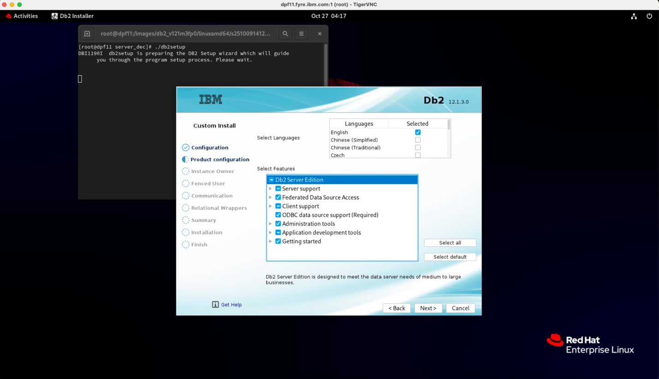

### Define who runs the show – Instance Owner Configuration

**Time to set up the boss of your Db2 instance – the primary administrator for your Db2 environment.**

The installer will pre-fill details like username, group name, and home directory for you (modify these if necessary). Just add a strong password and you are good to go. Hit *Next*.

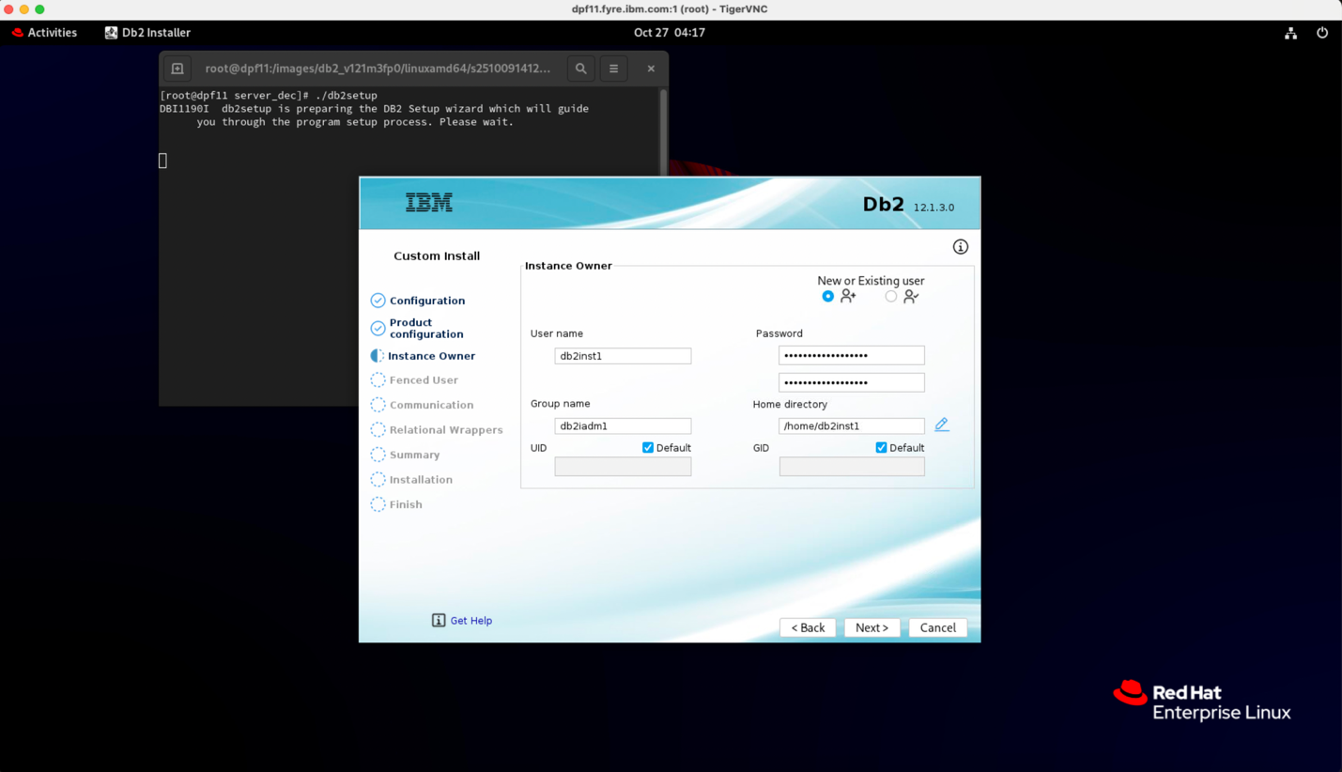

### Protect your instance - Fenced User Configuration

Now it’s time to setup the fenced user – the safety net for your Db2 instance.

As in the previous step, adjust any installer pre-filled values if necessary, add a strong password and click *Next* to proceed.

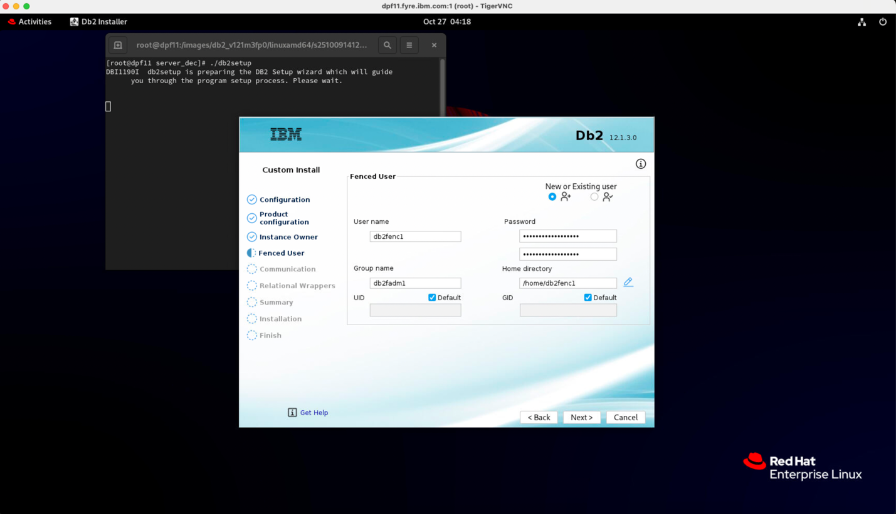

### Instance Communication checkpoint

On the *Instance Communication* screen, review the installer pre-filled values and modify if necessary. Hit *Next*.

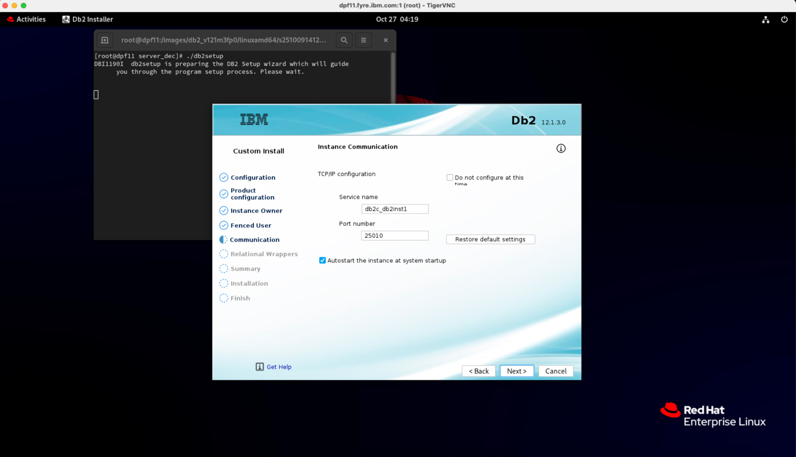

### Relational Wrappers

On the *Relational Wrappers* screen, decide if you need any relational wrapper components to connect Db2 with other relational databases. This step is optional, so, if you don’t need this and wish to keep things simple, leave the default selection (No) unchanged. Click *Next* to land on the Summary screen.

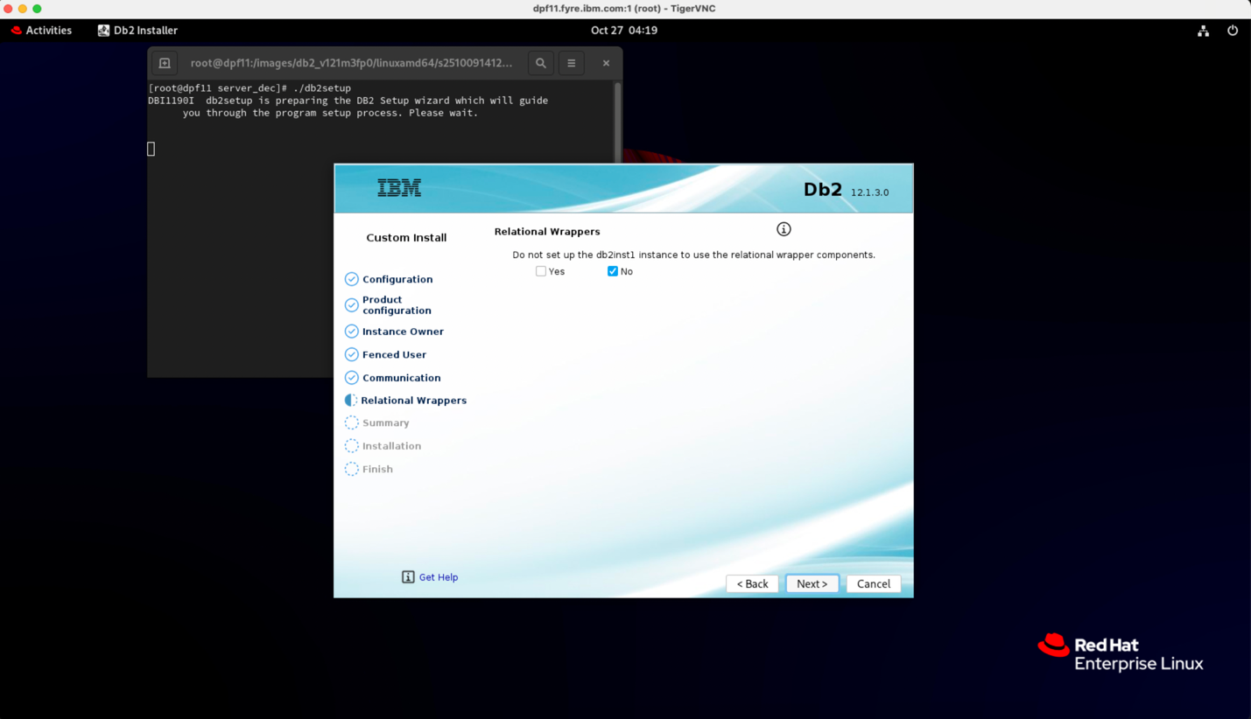

### The Final Stop before Installation - Summary

Once you land on the *Summary* screen, confirm that the option 'Install on this computer and save my settings in a response file' is selected. Hit *Next* to start the Db2 DPF installation.

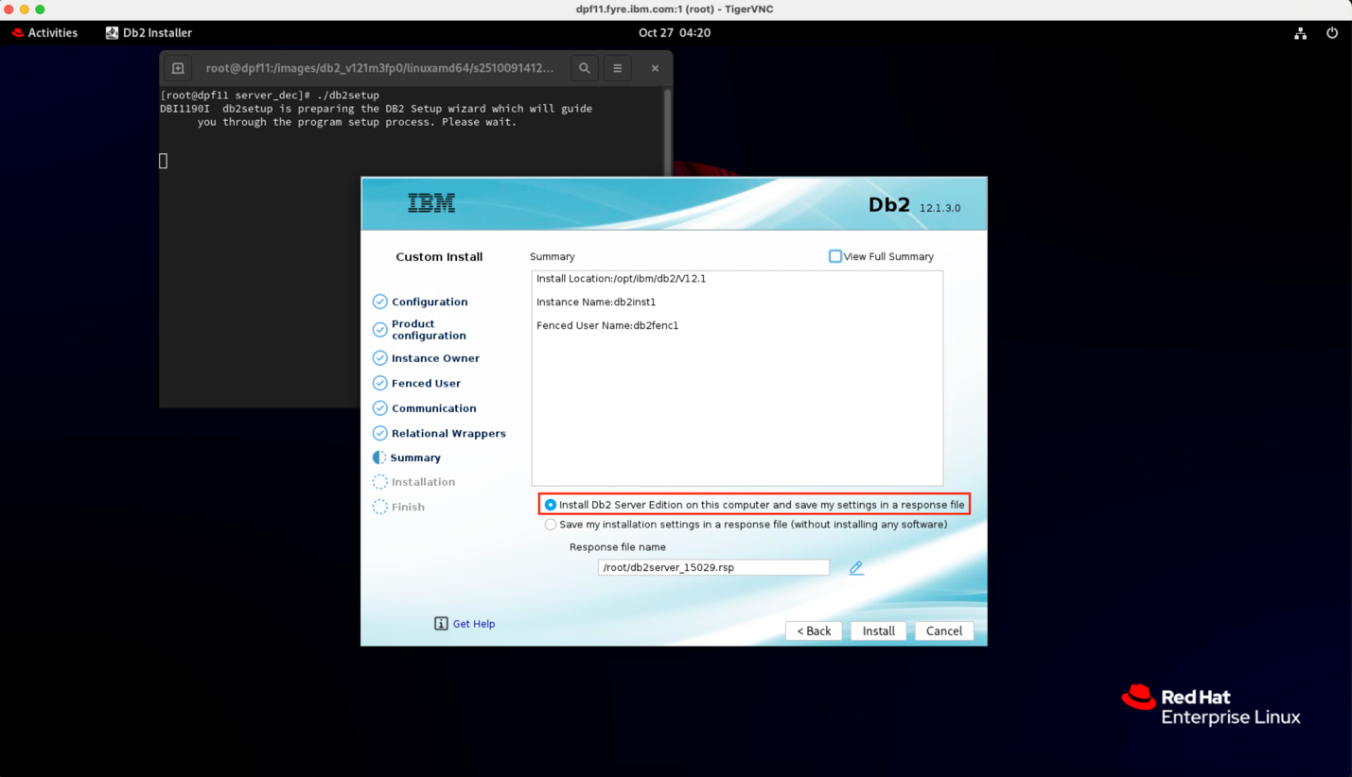

### Installing…. Almost there!

Sit back and watch the progress as Db2 DPF installs.

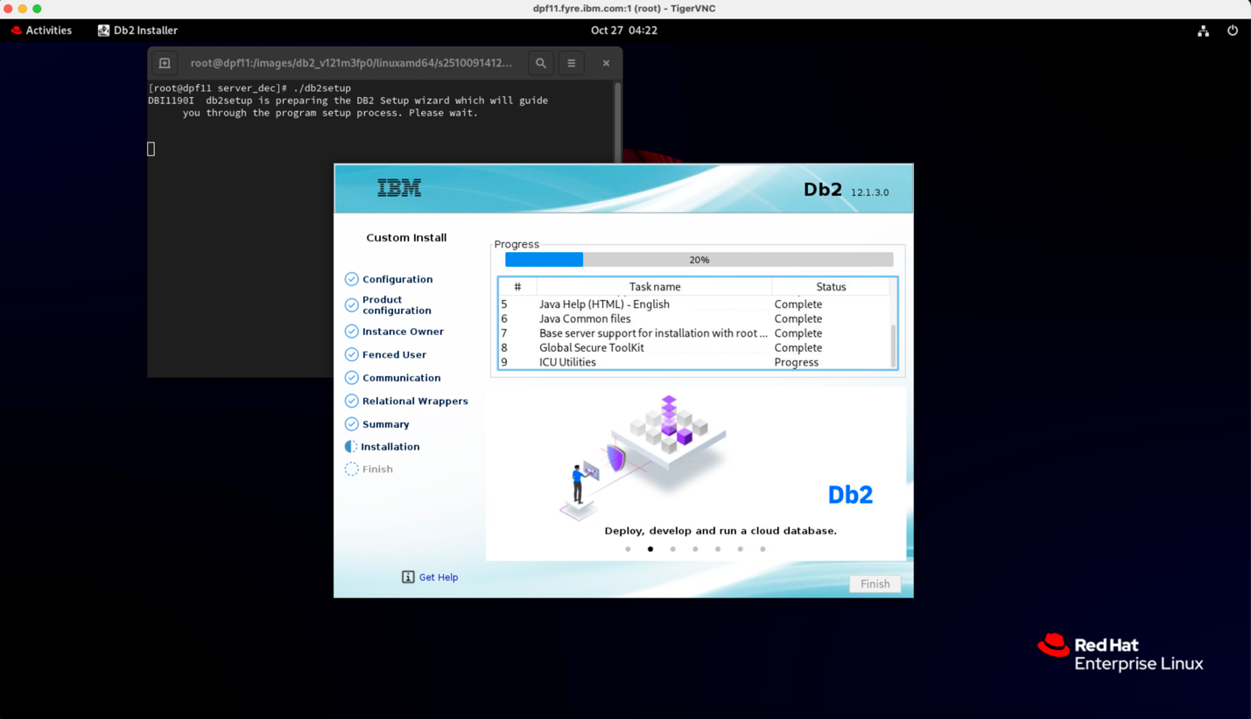

### Phase 1 Complete – Main Host Ready

Once the installation wraps up successfully, click ***Finish*** to finalize the setup on your main DPF host machine. Move on to the next steps to configure other DPF hosts.

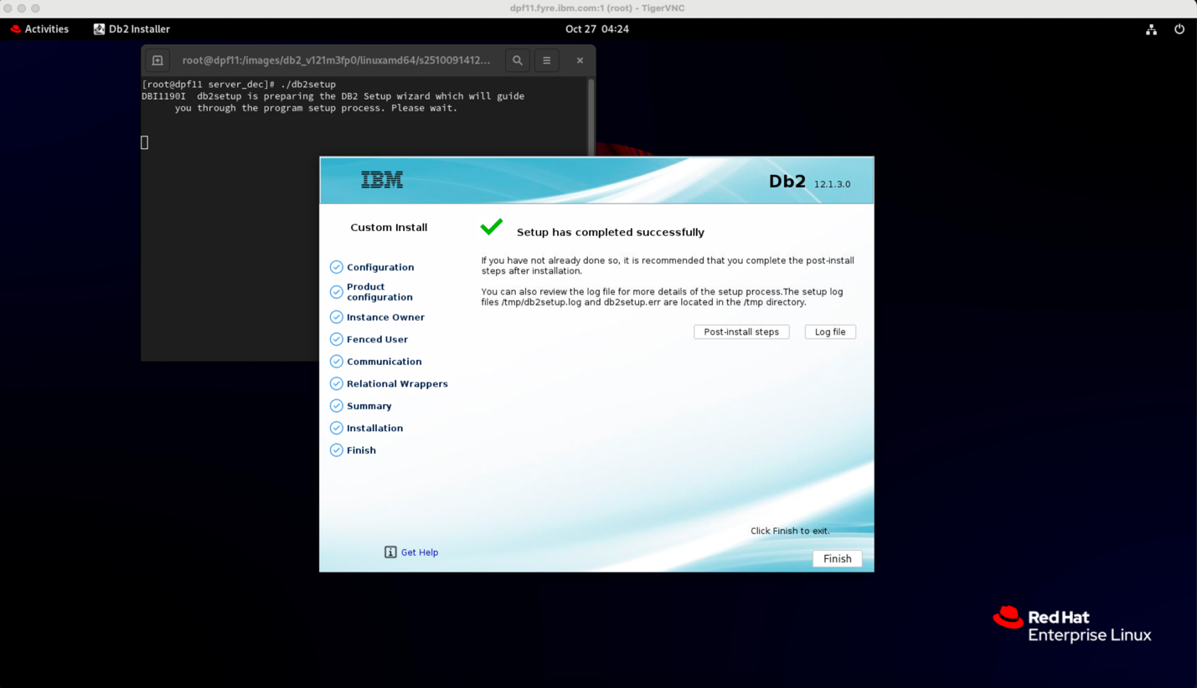

### Response Files – Your Key to Scaling the Setup

After the installation completes, two response files are generated in the path you specified on the *Summary* screen (Step 10):

* *db2server_<processID>.rsp* – This file captures all the details of the current installation.
* *db2server_<processID>_addpart.rsp* – Copy this file to your other DPF machines. It’s your shortcut to replicating the configuration without manual effort!

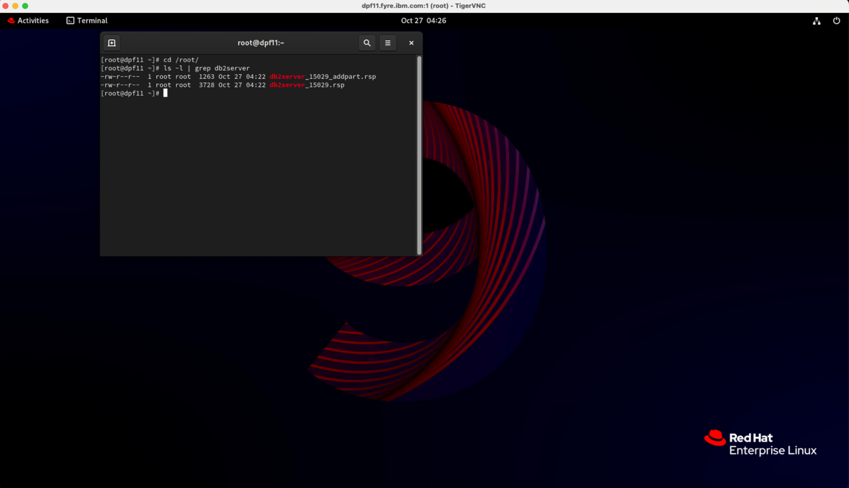

Using these response files ensures consistency across all nodes and saves time during multi-partition setup.

### Scale it Up - Configure other DPF hosts

On each additional DPF machine, run a silent installation with the *db2server_<processID>_addpart.rsp* response file using:

./db2setup -r db2server_<processID>_addpart.rsp

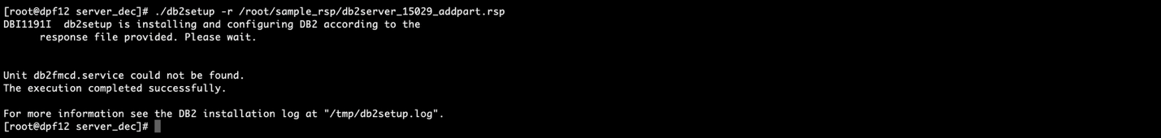

Doing this ensures your configuration is replicated perfectly across all the other nodes.

Once you’ve completed the silent installation on all DPF nodes, your Db2 DPF is at your service and ready to deliver.

## Wrapping-Up – Few Handy Links & Tips

### **Get started with Db2 Community Edition**

New to Db2 and not sure where to begin? The [Db2 Community Edition](https://www.ibm.com/products/db2/get-started#Download+Db2+Community+Edition) is a great starting point for your Db2 journey—free, feature-rich, and beginner-friendly.

### Setup the partitioned environment

Checkout the official IBM documentation on [Preparing to install the Db2 Database partitioned environment](https://www.ibm.com/docs/en/db2/12.1.x?topic=environment-preparing-install-db2-partitioned-database) to ensure your environment is properly setup across all the participating machines.

### **Want to dive deeper into Partitioned Databases?**

Checkout the official IBM documentation on [Partitioned database environments](https://www.ibm.com/docs/en/db2/12.1.0?topic=partitions-partitioned-database-environments) . It gives key insights into concepts like Parallelism, Database partition groups, Managing database partitions etc.

### **Optimize your GUI installer experience**

For the best visual experience, use a high desktop resolution when working with the Db2 GUI installer. All screenshots in this blog were captured via [TigerVNC](https://tigervnc.org/) on a Mac, connected to a RHEL 9.6 server running GNOME desktop. VNC server resolution of 2000×1200 delivered excellent clarity on this setup. Lower resolution like 800×600 can distort interface elements and give you a less polished experience.

### Root Access required

Setting up partitioned databases require root access – so ensure the installations steps are run with root privilleges.

## About the Authors

Austin Clifford is a Senior Technical Staff Member in Hybrid Data Management based in the Ireland Lab. He has worked with database, data lake and warehousing technologies for more than two decades. In 2012, Austin led the team to achieve a Guinness World Record for the Largest Data Warehouse, a record that IBM held for two years. Austin has authored numerous papers and patents, advises clients on data warehouse, analytics and containerization best practices and is a regular speaker at technical conferences.

Nitin Gupta is a Senior Developer at IBM primarily working with Db2 Engine, based in Bengaluru. He is also actively involved with various deployment related initiatives across release cycles. He has also authored a patent, and is actively engaged in resolving client challenges, particularly in the area of connectivity. In addition to his development responsibilities, he leads code review efforts, upholding high standards of quality and helping deliver defect-free solutions.

Ardra M is a Software Developer at IBM, currently working with the Db2 Deployment team in Kochi, Kerala. She plays a vital role in enhancing deployment support for new platforms during each release cycle, contributing to the scalability and adaptability of Db2. Ardra has also driven automation efforts in streamlining repetitive deployment tasks to improve efficiency. Known for her proactive mindset, she consistently demonstrates a strong willingness to take on new initiatives and is a quick learner with a keen interest in emerging technologies.